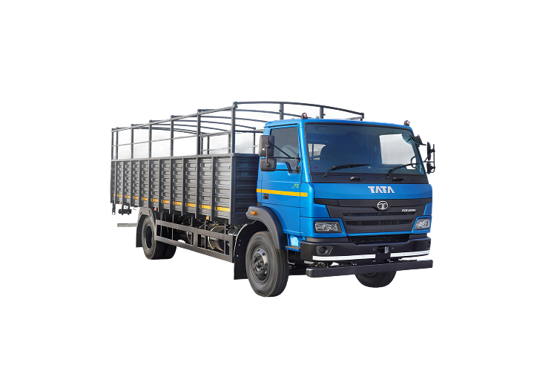

David Brown 1212
- About the tractor
- Gallery
- David Brown 1212 specifications
- David Brown 1212 serial numbers
- David Brown 1212 manuals

About the tractor
The David Brown 1212 was a versatile two-wheel drive utility tractor built at the Meltham Mills plant between 1971 and 1976. It was powered by a robust 3.6 L (219 ci) four-cylinder diesel engine, delivering approximately 71 hp (52.9 kW) at 2,300 rpm.
A standout feature of the 1212 was its Hydra-Shift partial power-shift transmission, offering 12 forward and 4 reverse gears with clutchless, on-the-move shifting—an upgrade from the earlier 1200’s manual gearbox. The hydraulic system was an open-centre design with around 2,000 psi pressure and a flow rate near 6.9 gpm, making it compatible with medium-duty farm implements.
With an independent 540/1000 RPM PTO, power steering, optional cab, and lift capacity of roughly 2,200 lb recommended (up to 4,400 lb max), the 1212 suited loader work and versatile task. Operators have noted that “if you take good care of it, [it] will last many years without giving you any trouble” .
In summary, the David Brown 1212 combined modern transmission tech, reliable diesel power, and solid hydraulics in a compact and user‑friendly package, making it a dependable farmer’s workhorse of the 1970s.

Gallery
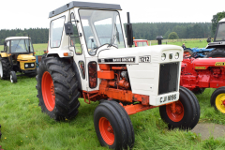

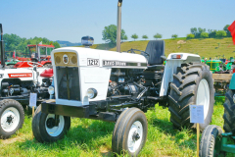

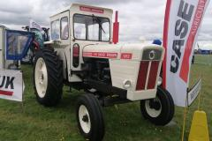

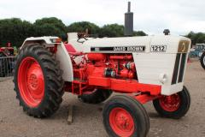

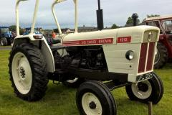

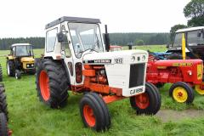

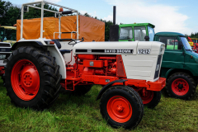

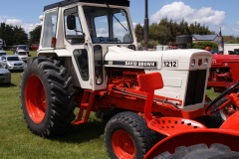

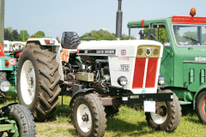

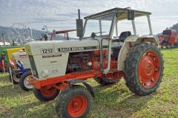

Engines
- 4SPCR BS6 71hp@2,300rpm
- NG 3.6L CR BS6 OBD Phase-II 71hp@2,300rpm

Deck Height
- 17 ft / 20 ft / 22 ft / 24 ft

Tyres
- 8.25R20-16 [PR]

Applications
- Auto Logistics, Parcel & courier E-commerce, Pharma, Fruits & Vegetables, FMCG (FM)

David Brown 1212 manuals
CASE / David Brown 885, 995, 1210, 1212, 1410 and 1412
Shop Service Manual / Parts catalog – download PDF
(89 pages)
CASE / David Brown 885, 995, 1210, 1212, 1410 and 1412
Shop Service Manual / Parts catalog – download PDF
(89 pages) – another copy of the same document
David Brown 990, 995, 996, 1210, 1212, 1410 and 1412
Steering and Front -Axle – download PDF
(42 pages)

